ULTRASONIC TRANSDUCER DRIVER AND RECIEVER

Hi folks. This kit is for more experienced hobbyists. I will not be going into fine detail with this kit. If you have purchased this kit, and you are having problems, let me know. I can act as tech support.

1) The Driver:
Both ultrasonic transducers in this kit are the same. They can be used to transmit and receive. Neat, eh? So as you can see, one pin of the transducer is tied to a voltage divider. The other is tied to a resistors that is in series with VCC (5VDC-12VDC), and an NPN transistor. The 555 timer is in astable mode, and is creating a frequency of roughly 40kHz. You can modify this design so that you can transmit when a button is pressed by placing a 10k ohm resistor between the ground line and pin4 (Reset pin), and placing an SPST switch between pin 4 and VCC. The 10k resistor is a pull-down. Remember, this is an option you have, and I do not supply this with the kit. If you have an oscilloscope handy, you can test the circuit by placing your probe each pin of the transducer (While transmitting). You should see a roughly 40kHz signal. It will be a slightly distorted signal between the voltage divider, but you’ll find a more coherent signal at the collector of the NPJN transistor (Second transducer pin). Easy, eh?

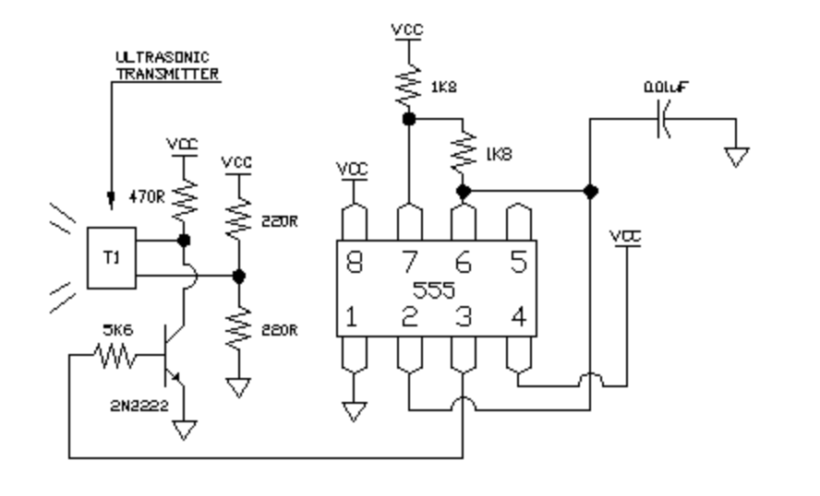
2) Receiver Power Supply:
Here is your simple power supply for the receiver circuit.
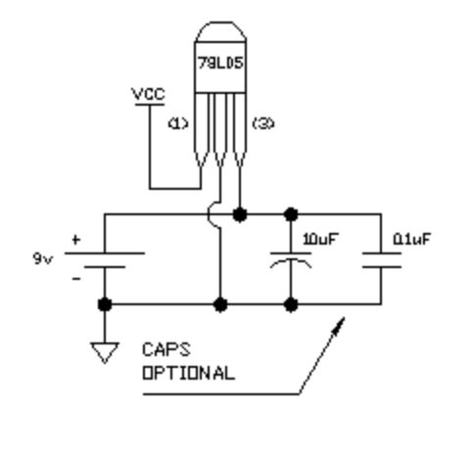
Don’t place more than 12VDC at the input of the 78L05 5v regulator. Make sure you’re not shorting any pins before you power your unit on. The 78L05 won’t be able to take it. The 10uf and 0.1uf caps are for protection. The VCC line is your 5VDC output.

3) The Receiver:
Remember, your VCC line is 5VC here. This circuit was designed that way. All we have here is a three stage passive amplifier circuit. If you’re going to have problems, they are going to be here. This isn’t a lesson, so I’m not going to get into amplifier circuits. I will tell you that the first and last stage are high gain. Each stage is coupled by a capacitor to get rid of the DC component. At the end of the third stage, the amplified signal is coupled through a final 10uf capacitor, and fed into the positive input of a comparator (LM386). This will give you a square wave TTL output when the a strong signal is being received. Now, notice the voltage divider at the negative input. This places a small voltage at the negative input at all times. This sets a standard. If your signal is not strong enough, then you will not get a square wave at the output. What you have the option of doing here is this:

Find a 10k potentiometer (Variable resistor). Place the wiper (middle pin) to the negative input, the left pin to the VCC line, and the right pin to the ground line. This will allow for you to calibrate your circuit so that you can receive from further or closer distances. Neat, eh?
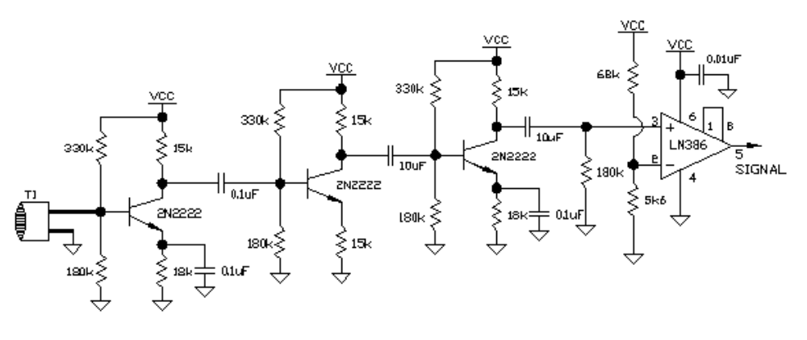

This kit is very basic. What you see in the schematics, is what you get in the kit. I hope you have fun with this kit, and if it doesn’t work right away, troubleshoot the circuit, starting with the receiver circuit. I’ve build this circuit at least 4 times, and I’ve modified it so that this this is what you get. Every time I build it, I make a mistake. It is bound to happen.

Thanks again for your patronage.

DESIGN BY: PATRICK MITCHELL
ELECTRONICS ENGINEERING TECHNICIAN

